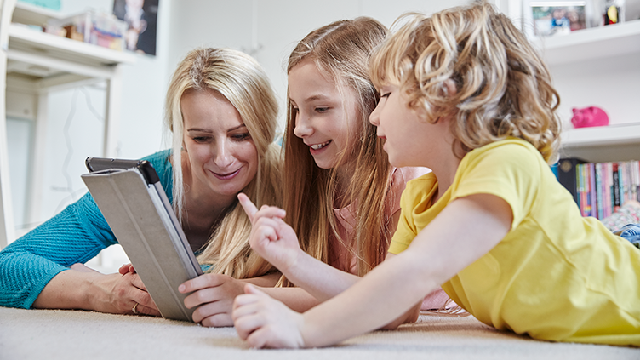

Online safety during the coronavirus pandemic
During the coronavirus (COVID-19) pandemic and lockdown, people are relying even more on online technology.
Most children are at home, away from their friends, peers and teachers, social distancing means that they may not have seen extended family in some time. This makes being online extra important for children and young people.
Many children are spending more time online – and expanding the ways they use the internet. They may join online communities or start using new video-calling platforms. Children who receive support from services may go online to contact social workers, counsellors and others in their support network.
While all this can bring benefits to children’s mental health and wellbeing, children can be exposed to risk online.

Online Risks
During the coronavirus pandemic, children may be at increased risk as they are online more often.
When children spend time online they may be exposed to:
- online abuse
- cyberbullying
- sexual exploitation
- sexting: advice for professionals
- sharing sexual messages, images and videos
- grooming
- radicalisation.

Reporting concerns
Concerns about online abuse or inappropriate behaviour should be reported to the person responsible for safeguarding issues within the school.

If you’re using social media or messaging/video apps to communicate with children as part of your work, you must consider safeguarding measures.

Remote teaching
In England, the Department for Education (DfE) has no expectation that teachers should livestream or pre-record lessons. Schools should consider the approaches that best suit the needs of their pupils and staff (DfE, 2020).
- If you do plan to record or livestream lessons via an online platform, you need to assess any risks and take appropriate actions to minimise harm.
- Teachers should be in a neutral area where nothing personal or inappropriate can be seen or heard in the background.
- Always make sure the platform you are using is suitable for the children’s age group. Set up school accounts for any online platforms you use (don’t use teachers’ personal accounts). Check the privacy settings.
Contacting children at home
While schools are closed staff might need to contact children individually, for example to give feedback on homework. Staff should only contact children during normal school hours, or at times agreed by the school leadership team (DfE, 2020).
- Remember the staff code of conduct
- Any one-to-one sessions, for example pastoral care meetings, should be risk assessed and approved by the school’s leadership team (DfE, 2020). Make sure staff know what safeguarding measures to take if they are having a one-to-one conversation with a child.
- Use parents’ or carers’ email addresses or phone numbers to communicate with children, unless this poses a safeguarding risk.
- Use school accounts to communicate via email or online platforms, never teachers’ personal accounts.
- Make sure any phone calls are made from a blocked number so teacher’s personal contact details are not visible.
- If staff members are accessing families’ contact details at home, ensure they comply with the Data Protection Act 2018.

Online behaviour

- use accounts that have been authorised by your organisation to communicate with children and young people (never use personal accounts)
- turn on privacy settings on accounts that are used to interact with children and young people
- use an organisational device to communicate with young people (if this isn’t possible, senior managers should authorise individual staff and volunteers to use a personal device on a case-by-case basis and keep a record of this authorisation and who can see the communication)
- ensure all communications are relevant to the work of the project and organisation
- use age-appropriate language.
- Staff and volunteers should also be aware of their digital footprint. Children, young people and families may look up the personal social media accounts of people who are working with them so these should be free of inappropriate or harmful content and not provide any personal information such as personal email addresses or phone numbers.
- Staff and volunteers must not accept friend requests on their personal accounts from children and families they work with.

Mental health and wellbeing
Children and young people may be worried about the impact of coronavirus, social distancing or self-isolation. Those who already have mental health difficulties such as anxiety might be finding things particularly tough. Talk to them about what’s happening, check how they’re feeling and keep them as well informed as you can.
Tell children and young people where they can go if they are worried about anything or need to talk to someone while school is closed.
Childline provides a range of online tools that young people might find helpful, calls to 0800 1111 are free or children can get support online.

Talking to children about online safety
You should continue to talk to the children and young people you work with about the benefits and risks of spending more time online.
Make sure that children know who they can talk to about online safety, whether that’s you, another trusted adult such as a parent or family member, or confidential services such as Childline.

