

**If you have any concerns about *the welfare of a young person at The Meadows* School:**

**Contact: 01538 225050**

**Staffordshire Childrens Advice and Support Service**

**Contact: 0300 111 8007**

**Cheshire East Consultation Service**

**Contact: 0300 123 5012 (opt 3)**

**Designated Safeguarding Lead:- Sarah Rubanski**

**Deputy Designated Safeguarding Lead:- Joan Wright**

**‘Safeguarding Children is Everyone’s Responsibility’**

**Safeguarding at The Meadows School**

**Statutory Guidance**

**Working Together to Safeguard Children 2018** Sets out how organisations and individuals should work together to safeguard and promote the welfare of children and young people in accordance with The Children Act 2004, including as amended by the Children and Social Work Act 2017 and associated regulations.

**Keeping Children Safe in Education 2021** Sets out what schools and colleges must do to safeguard and promote the welfare of children and young people under the age of 18.

Senior managers will demonstrate leadership, be informed about, and take responsibility for the actions of their staff who are providing services to children and their families. Senior managers are also responsible for monitoring the actions of staff to safeguard and promote the welfare of children. This includes ensuring that children and young people are listened to appropriately and concerns expressed about their or any other child’s welfare are taken seriously and responded to in an appropriate manner.



**Family Support Workers:-**

** ** 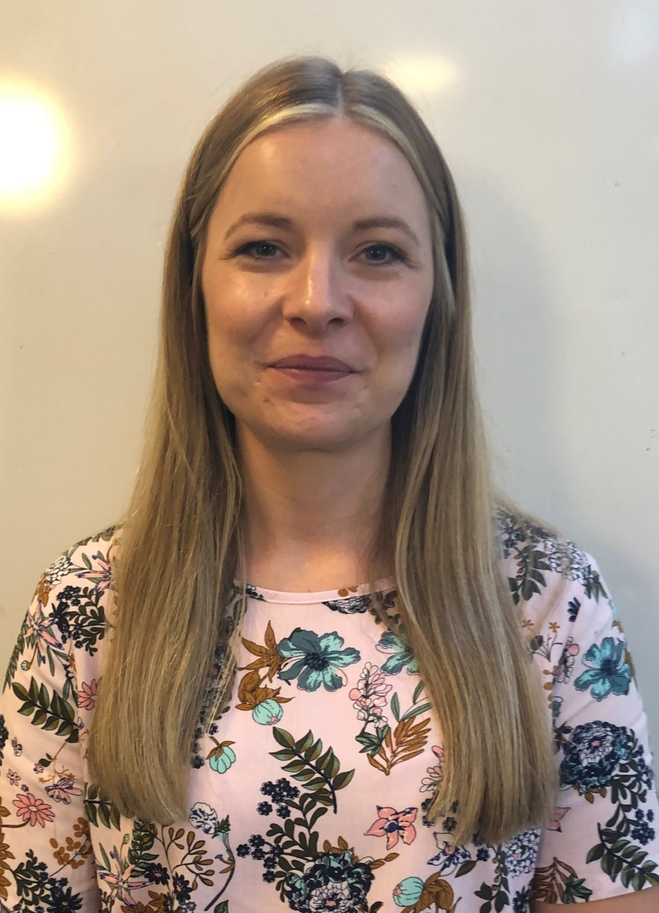

**Kieron Edridge Sarah Ashe** **Lauren Weaver**