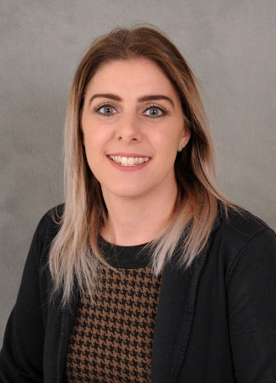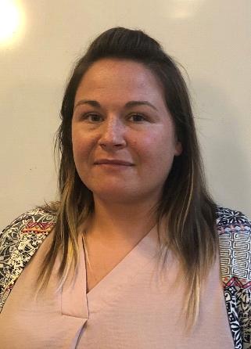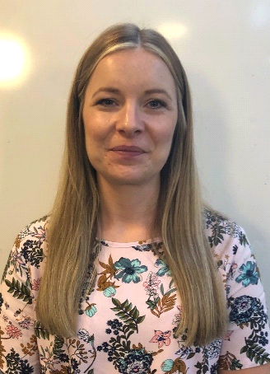

**Designated**

**Safeguarding Lead:**

**Sarah Rubanski**

**The Family Support Team work across Springfield and The Meadows School offering support to children, parents and carers.**

**We are based within the Family Hub where you can drop in at any time for advice, support or simply a cup of tea.**

**Please contact us at the Family Hub...**

**sarah.rubanski@the.meadows.manorhall.academy**

**01538 384161**

**Meet our**

**Family Support Workers:**

The Family Support team work across Springfield and The Meadows School offering support to children, parents and carers.

We are based within the Family Hub where you can drop in at any time for advice, support or simply a cup of tea.

Please contact us at the

Family Hub...

**Kieron Edridge Lauren Weaver Sarah Ashe**

The Family Support team work across Springfield and The Meadows School offering support to children, parents and carers.

We are based within the Family Hub where you can drop in at any time for advice, support or simply a cup of tea.

Please contact us at the

Family Hub...