Bet 365 Britannia Stadium
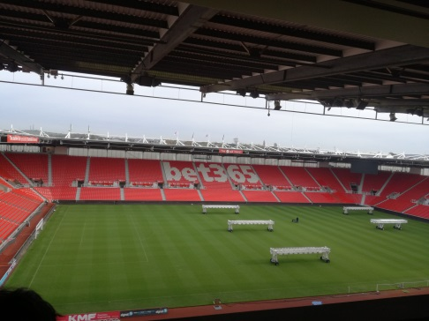
Wednesday 1st November 2017:
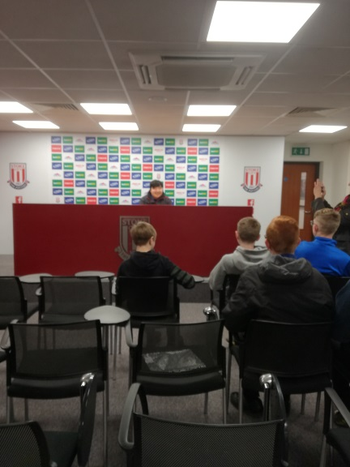
As a reward for completing the Unified Football Programme, 8 students from The Meadows had the opportunity to visit Stoke City’s football ground the ‘Bet 365 Britannia Stadium’ for a behind the scenes stadium tour.

When we arrived at the stadium, we were greeted by our tour guide, Jacob. He took us behind the scenes to places where only professionals can go! We were able to go into the Media Suite and the Sky Room and see where people like Gary Neville sit to record ‘Match of the Day’ and comment on the game. We went into the executive boxes which are owned by the sponsors that keep the club going.

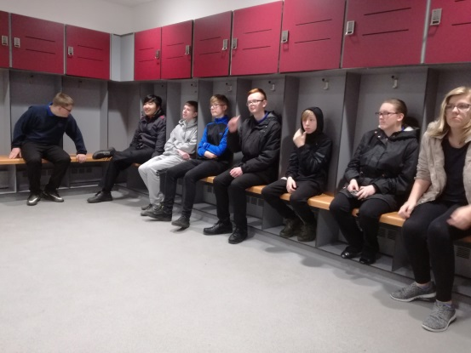
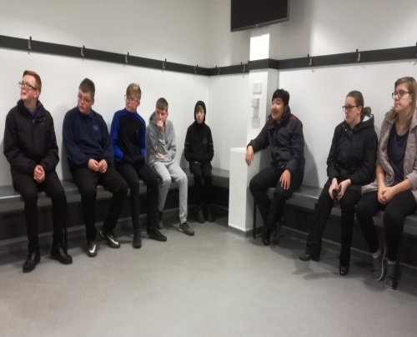
Once we had visited all of the executive suites, boxes, media room and photographer rooms, we went onto the ground floor and were allowed to go into the changing rooms both home and away. Jacob told us some interesting facts about the changing rooms, like the away team don’t have enough pegs for all of the team so all of the players have to squash together and share the space – this usually means that they are rather miserable before the game and don’t play their best. The home team have luxurious changing rooms, with a gymnasium and ice baths – we all got to sit in the changing rooms under the lockers where the players get ready and have their team talk before a game.
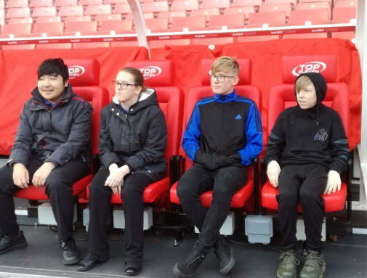
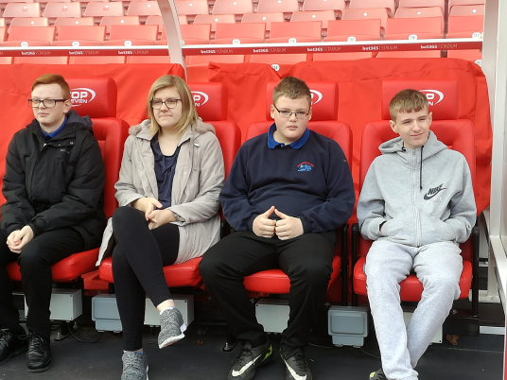
After the changing rooms we went out onto pitch side. Jacob told us lots of facts about the pitch – did you know the grounds man walks 65miles per week just mowing the grass at the ground! We were able to sit in the very seat where Stoke City’s manager Mark Hughes sits every home game. We were able to have lots of photographs by the pitch, but were not allowed to go on the grass because the grounds man and his team use expensive lamps that move along the grass to make it grow at a really fast rate to keep the pitch in excellent condition- but because of this it has to be mown twice a day to keep it at the right length for the games.

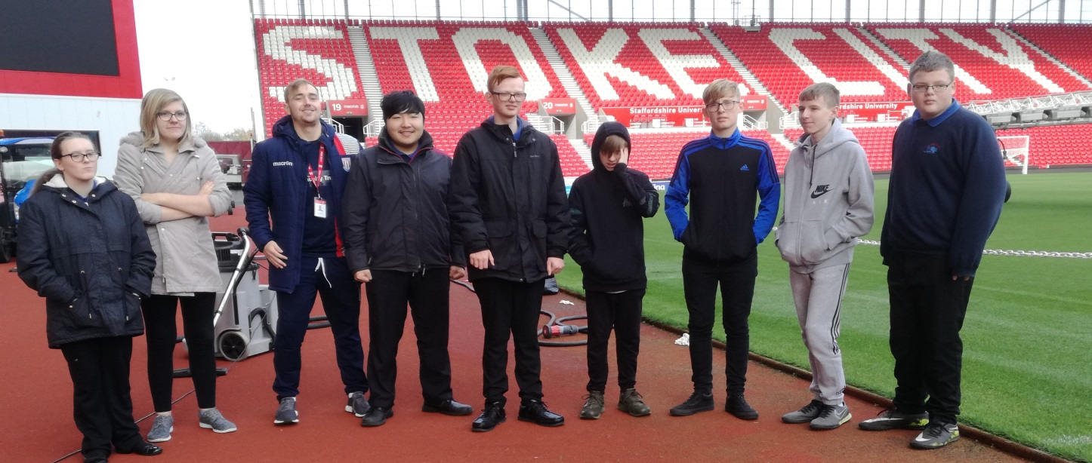
We had a super visit to the ground, and learnt lots about the stadium and team! The 8 students on the trip behaved superb, and Jacob even commented about how exceptional their behaviour was!

