The Meadows School

Germany Visit October 2017
After much excitement in the weeks running up to our Germany Visit, the evening of Sunday 15th October finally arrived and a group of 26 students, 6 staff and 1 brave parent, Miss Linda, met on the school carpark. Everyone was VERY excited, and after a slight delay the coach pulled up at school and we loaded up our suitcases, found our seats, and off we set…. Our big German adventure was beginning!
We had an early morning ferry crossing from Dover and even though it was still quite dark, we could still make out the famous white cliffs as we stood on the deck and waved England goodbye. We were lucky that the sea was very calm and we had a smooth crossing. We all sat down to enjoy breakfast and a drink and as we approached France we were treated to a beautiful sunrise.
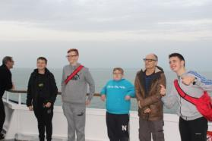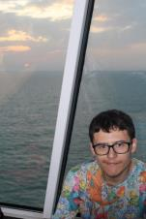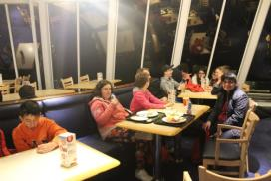
After an enjoyable crossing we arrived in Dunkirk and began the drive through France to reach Germany. We had a lunch stop at a French service station and Mr Pritchard helped everyone with the translation of the menu and students were able to practice their French skills.
Eventually we crossed into Germany and we soon found ourselves in the stunning Black Forest region. The scenery was beautiful and, as we drove mile after mile through forest clad hills and past scenic towns and villages, we finally arrived at the lovely town of Triberg and the youth hostel which was to be our home for the next 5 days.
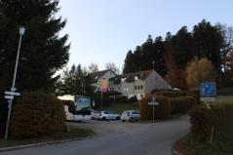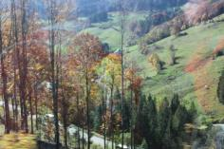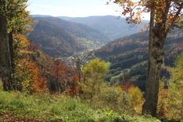
The youth hostel ensured we had a warm evening meal when we arrived and we settled down to a much needed sleep in our rooms, excited to see what the next day would bring.
Everyone slept well and the next morning we all met for breakfast which was a choice of meats, cheeses, bread, yoghurt and cereals; a continental breakfast. There was a very bright blue juice, which none of us could quite make out what it was, but it tasted nice!
After we were all fed and watered, we were back on the coach again and heading to Freiberg, a beautiful town where we were able to visit the stalls in the market square and cathedral and had the opportunity to buy some gifts and souvenirs. The Black Forest region is famous for clocks and in particular Cuckoo Clocks and these were on display in many of the shops. We were all impressed by them and Mrs Ball even bought one to take home.
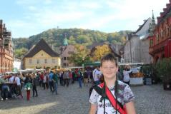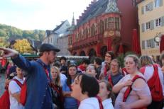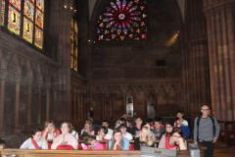
Mr Best received a lovely email whilst were there from a teacher from a school in Suffolk who had seen our group, which said:-
“I am currently myself on a trip to Germany with my school. Your school are in Freiburg and I just had to email to let you know what a fabulous group they are. Pupils and staff are clearly having a great time. You should be very proud. “
We re-joined the coach and headed into the mountains for a picnic stop. And what a spot it was! The view was spectacular and the sun was out for us, in fact it was very warm, which we were told was very unusual for the time of year.
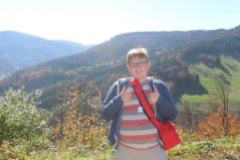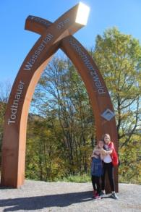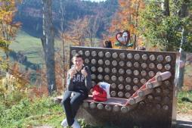
Some of us took a downhill path to see a waterfall which was worth the walk as it was a beautiful spot.
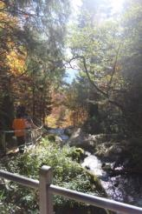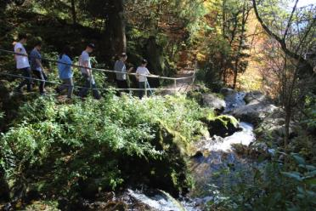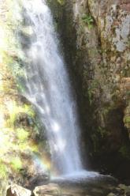
Our journey continued, and our next stop was one which many of the students had been looking forward to... the Toboggan Run! There are quite a few of these dotted round the Black Forest we noticed as we passed through the region, but the one which we were booked on did look to be the largest! Those of us who chose to do the toboggan run firstly had to brave the ski-lift chair ride up the side of the mountain, which was a feat in itself. Once at the top, we were sat in sledge like seats, in pairs, and we whizzed back down the mountain on the toboggan track. It was so high it took about 10 minutes to get from the top of the mountain to the bottom, but we were rewarded with the most fantastic views over the valley. Everyone thoroughly enjoyed it and instantly wanted to go back up and do it again, but unfortunately it was time to head back to the hostel for our evening meal. After a lovely tea, some students chose to stay at the hostel for the evening and played games and did activities with the staff. Table football was popular! Mr Best, Mr Pritchard and Mrs Best took a small group of children out for a walk into the town in which we were staying, Triberg, which looked very pretty lit up in the evening.
At the end of a busy day we all turned in for the night, ready for a good sleep!
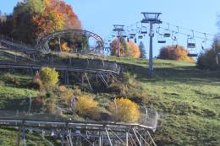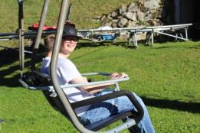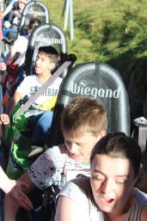
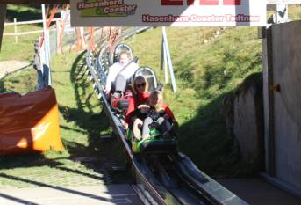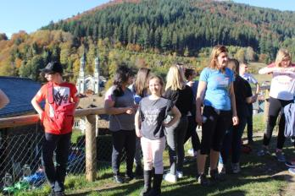
Wednesday morning saw us up early and once we had enjoyed our breakfast we were back on the coach again, this time travelling to the city of Strasbourg, which is actually sits in France, just over the border of Germany. We headed to the cathedral where we were being met by our tour guide who took us on a walk to the different areas of the city and told us some interesting facts and stories about the city’s history. We finished the walking tour at a park, which was the perfect spot for us to stop and re-charge our batteries and to eat lunch. We then made our way back through the city, taking in the sights and having a bit of time to pop into a shop for those all-important souvenirs and gifts to take back to family in England. Cameron treated himself to a flat cap, obviously Mr Best’s winning fashion sense being the inspiration behind the purchase! Next up was a pre-booked River Cruise which gave us a different perspective of the city as we travelled along the river. The boat even had to negotiate a couple of locks as the water levels on the river changed. We had headphones on the boat and were able to listen to commentary of what we were seeing as we cruised along. We passed by a large, modern, glass building which is the official seat of the European Parliament. Strasbourg is a lovely city with beautiful buildings, especially the old, medieval town and is well worth a visit should you have chance.
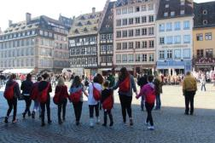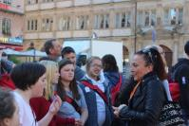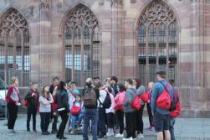
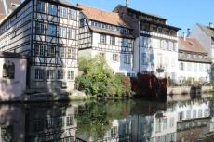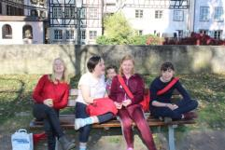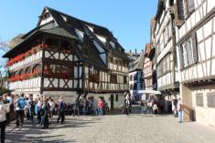
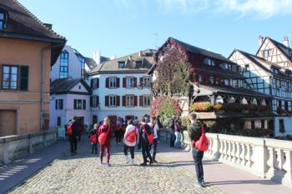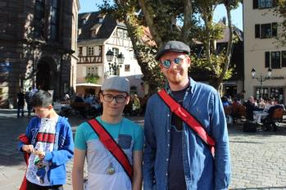
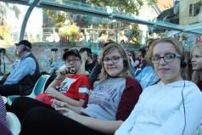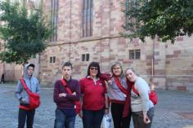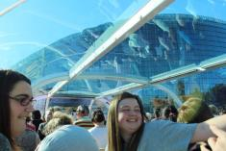
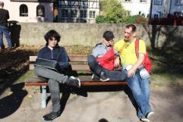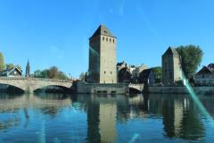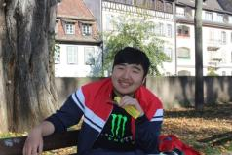
We departed Strasbourg late in the afternoon to head back to the hostel for the evening, and again students had the choice to stay and play games at the hostel or to take a night-time walk. Armed with torches, a group of us headed into the forest, which surrounded the hostel and we had lots of fun walking through the darkness! Did somebody say Bears?!
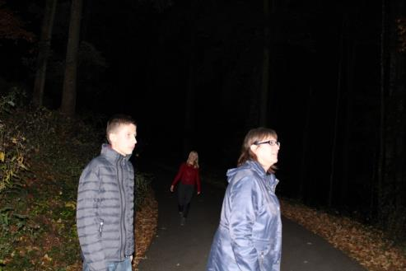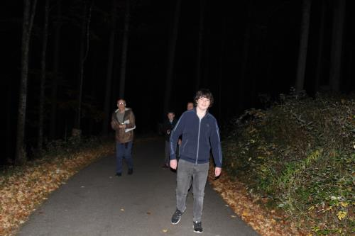
Our last day, Thursday, was another beautifully sunny day as we headed to Europa Theme Park, which is one of the largest and most popular theme parks in the whole of Europe. The park is split into different areas, with each area being a different European Country. Will was particularly excited and having visited the park previously he was our unofficial tour guide for the day! Once inside the park we took the Monorail ride across the park to a ride which Will recommended, Blue Fire, and it didn’t disappoint for those brave enough to have a go (or silly enough, depending on your view!) Mrs Ball, Mrs Best and Mr Davies went on with a number of the students and we all said that it was one of the best rollercoasters we had ever been on. Next up was a huge wooden roller coaster called Woden, which was very fast and high and left us all with the giggles and wobbly legs. Some students chose to go on the Water Rapids and Pirate Ship. At lunchtime we found a little area to sit and have our packed lunches before we split into two groups, one group to continue with the white-knuckle rides and the others to try more sedate, less scary rides. The whole park was decorated for Halloween with pumpkins and displays and it looked very attractive. Everyone thoroughly enjoyed themselves and all too soon it was time to leave, despite the protests of not wanting to go! Once we were back at the hostel we enjoyed our final evening meal there – the food throughout our stay was lovely with something for everyone – and then it was time to pack our cases in readiness for the journey home the next day. Again the evening was spent either playing games in the hostel, or braving one of Mr Best & Mr Pritchard’s night-time walks!
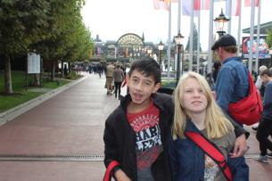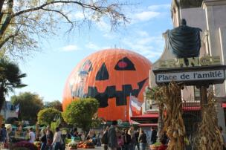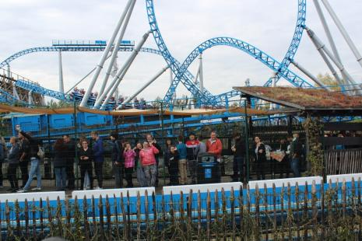
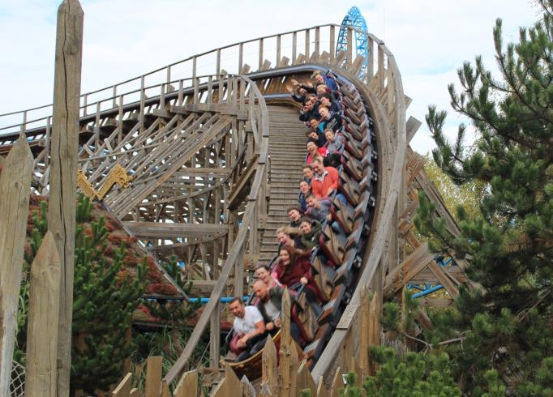
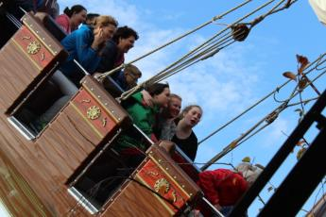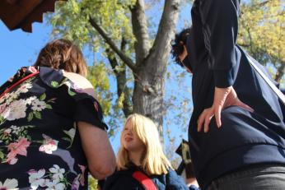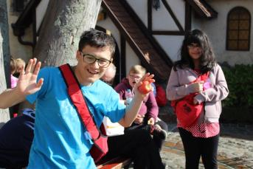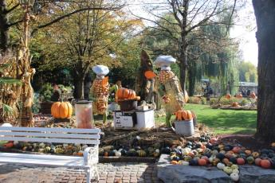
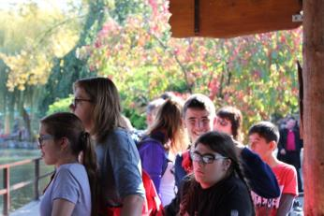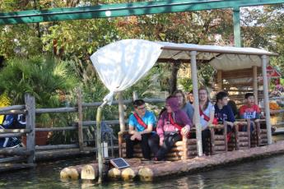
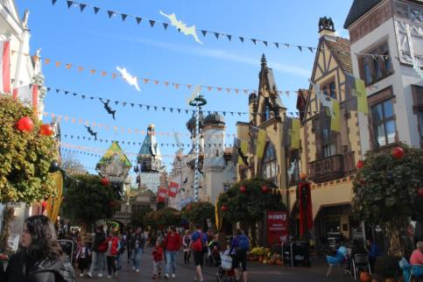
We woke up Friday very early and having previously packed the night before, once we had eaten breakfast we were once again back on the coach for the long journey back to England. As Harvey said ‘I feel like this coach is my new home!’ We reached Dunkirk for our evening ferry crossing back to Dover but unfortunately this time the weather wasn’t as kind to us as the crossing into France and we definitely needed our sea-legs. We eventually arrived back at school later than anticipated, all excited to see our families again and to go home for a much needed sleep in our beds.
The whole trip was a fantastic success and Mr Pritchard and Mr Best were overheard on the coach planning, or should that be plotting?, the next Meadows School overseas adventure. We hope you will be joining us for fun, adventure, new experiences, a sense of independence and above all laughter. See you there!

Class of ‘17

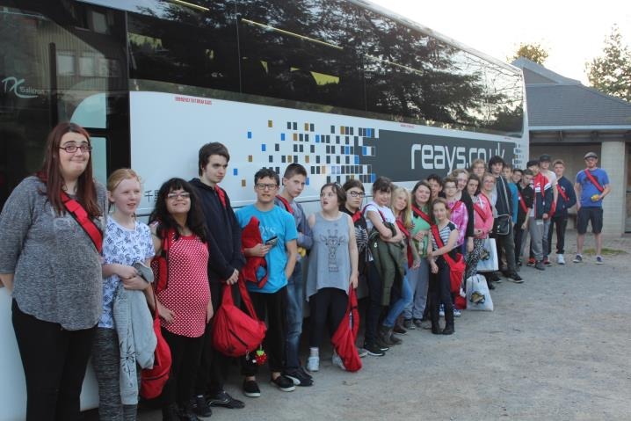
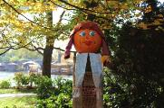
“Auf Wiedersehen!”
Rachel Gaulton-Best

