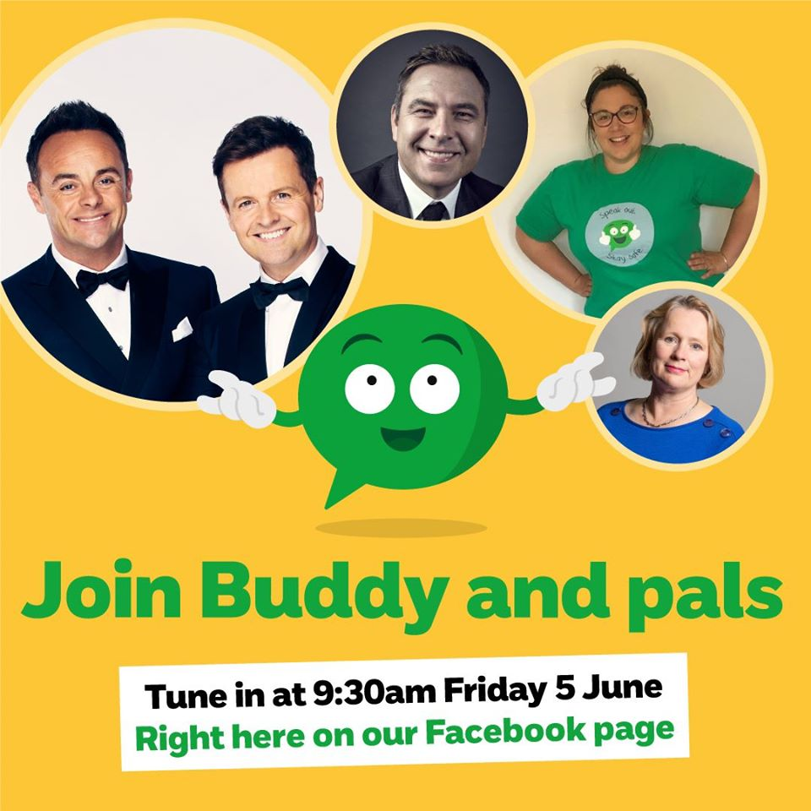

Over the years, our Speak out Stay safe assemblies have taken place in more than 90% of all primary schools across the UK, giving children the knowledge they need to stay safe from harm and to speak out if they're worried.  
  
While we aren't able to run our assemblies as normal right now, we are SO excited to announce that next Friday June 5th we'll be hosting our very own VIRTUAL Speak out Stay safe assembly alongside some VERY special guests... Drumroll please... 🥁   
  
⭐️ [Ant and Dec](https://www.facebook.com/AntAndDec/?__xts__%5B0%5D=68.ARD6RPvgMmrnwO_mxE4pANIjBUCfrlniHNTN2aeikCMUqC5nMbG-5SZYwN3t-MqaLayESYlcWPewGSg-HjjUpx1VF7vyPuK0z4loaoCIgJb9uciwv5JjCgj02pdvICiDuGIFrkM3MnMGShb2GdmVpxy7QGDgFyyFvHM-WOuvPpPN-5fANiZEbV8yu3PloqIW24LpvXDqBeb7MTTNCO-S8aurERbqw6tXT0gcJdhZUPMRURdEDKRZfqLVs9iar1ouMYOEfM7ssxMG0o65KKy5pH1b2hxIaxj22aBpkmGZcRC-EsrWkubbeM0xfur7QumnSv6T681IqDhHj1mqyA)  
⭐️ David Walliams  
⭐️ Children and Families Minister Vicky Ford MP!  
  
Tune in as a family, right here on our Facebook page from 9.30am.  
  
Please share and help us spread the word!  
  
Find out more about the Speak out Stay safe programme here: <https://bit.ly/3erV1Tj>

[Type a quote from the document or the summary of an interesting point. You can position the text box anywhere in the document. Use the Drawing Tools tab to change the formatting of the pull quote text box.]