Report on the Battlefields Tour – “Ours is the Legacy”

Jack, Brandon, Mrs Ball and Mrs Wright had a wonderful four day trip, which was jam packed with experiences and memories to last a lifetime. We travelled to Belgium with a diverse group of staff and students from other schools and stayed in Flanders Lodge in the town of Ypres. We were accompanied by highly skilled battlefield guides and also modern day soldiers from the Army and Territorial Army who explained a lot of details to us. They gave us the perspective of a soldier’s daily life in 1914 and contrasted it with military life in 2015. We looked at uniforms, food and equipment from World War I, comparing it with the highly sophisticated “ration packs”, protective uniforms and lifesaving equipment of today. It was pointed out to us that those who died in WWI were buried (if their bodies were recovered) near to where they fell, whereas today the Armed Forces return any deceased personnel back home for Repatriation. Thankfully today, numbers are much lower.
Highlights included handling artefacts from the First World War including grenades, shells, gas masks and rifles. Brandon, Jack and Mrs Ball made pottery sculptures that will become part of a display of 600,000 such sculptures that will commemorate the 600,000 who died in Flanders Field one hundred years ago.
The biggest moment came when Jack and Brandon, wearing their Meadows school uniform, and each carrying a poppy wreath were chosen to take part in the moving Menin Gate Ceremony, where they honoured “The Missing” and especially those from Leek, whom we had researched prior to the visit to keep their memory alive. The homage below was read and the minutes silence was observed.
“At the going down of the sun, and in the morning
We will remember them.
We will remember them.”
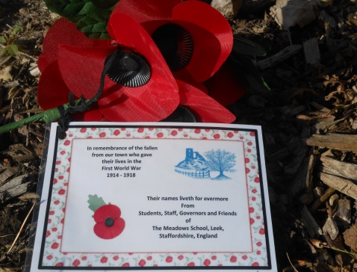
On the Thiepval Memorial, again to “The Missing”: that is those whose bodies were never found, we laid our wreathes and tributes to Leigh Richmond Roose who was a goalkeeper for Stoke City FC and a Welsh International, and ‘Sammy’ Hulme who was a trainer for Leek Alexandra FC. We also laid a wreath in memory of Ernest Flower whose great, great nephews and niece attend Leek High School.

We also visited British, Indian and German cemeteries as well as The Flanders Field Museum in Ypres and the Death Cells at Poperinge where over thirty men spent their last evening before being shot for cowardice. As Mr Richard Mace, history teacher at Leek High School commented, “It was all immensely moving and thought provoking and this programme ensures that a vital part of the past is not lost as History marches on.”
Brandon and Jack were ambassadors for The Meadows School and their families and they themselves and our whole school community can be proud of them. Well done; you have played your part in ensuring that
“Their Name Liveth For Evermore”

