The Glorious Game – Footballers Remembered

Football, one of the national sports in the United Kingdom has always reflected social change. Some of the Northern and Midlands football teams had their roots in local teams started by factory owners who promoted additional loyalty to the place of work. The idea of a 3pm ‘kick off’ on a Saturday afternoon fitting in with the Saturday morning requirement to attend work…. And then off to the match. Indeed economic growth, employment and success within a town or city may be mirrored in the achievements of the football team, or the rivalry between clubs within a city with more than one team. Alliance to your team, with tactics discussed throughout the often tedious working week, lightened many peoples lives.
On The Thiepval Memorial in The Somme the names of at least thirty-three footballers are remembered among “The Missing”. Those who have no known grave. Footballers were among those who volunteered to fight “For King and Country”, alongside every other trade or profession.
Two students from The Meadows School, Brandon Lucking and Jack Hickman, researched the lives of two local footballers who were killed in 1916 and found their names among the 72,194 officers and men of the United Kingdom and South African forces remembered on Sir Edwin Lutyens red brick and limestone memorial.
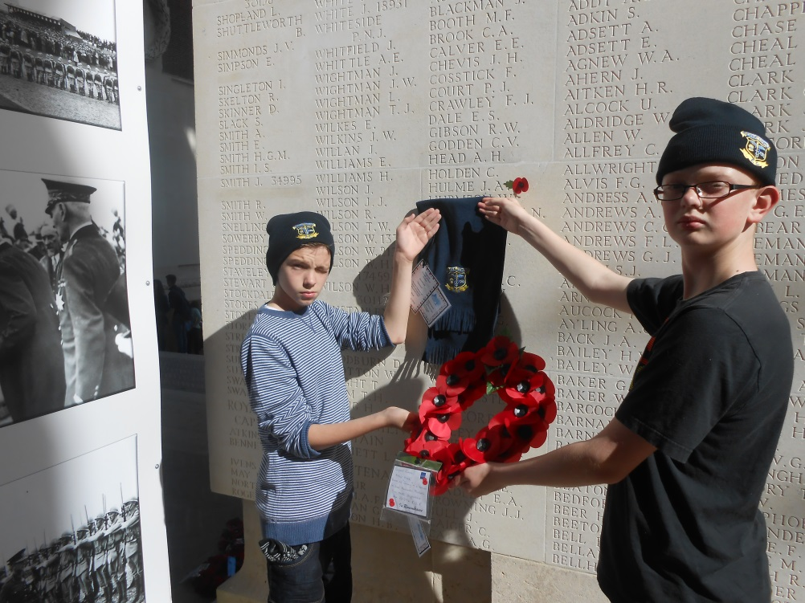
Joseph Arthur Hulme, known as ‘Sammy’ played for Lincoln City, Bristol Rovers and Brighton & Hove Albion before becoming a trainer for Leek Alexandra Football Club. He lived at 9 Parker Street, Leek and was killed on the 3rd October 1916 – his age unknown. He was serving with The Royal Sussex Regiment and was one of four friends who joined up together and never returned to Leek, giving their lives with the ultimate sacrifice. 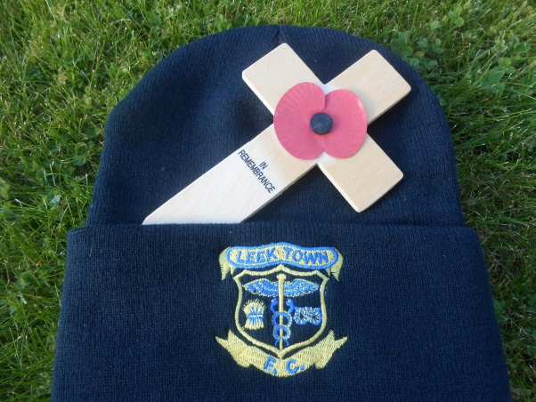

Brandon and Jack found Sammy Hulme listed on one of the pillars of the memorial and added a poppy beside his name. We were able to place upon The Stone of Remembrance, situated in the raised section at the heart of The Thiepval Memorial, a Leek Town FC scarf and two hats together with a poppy wreath and a card dedicated to Corporal Hulme. The hats and scarf were donated by Leek Town FC. We hope that Leek Town may include a dedication to “one of their own” in their November Programme.

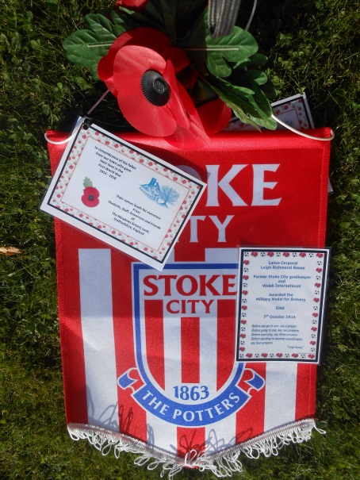
Lance Corporal Leigh Richmond Roose who was awarded the Military Medal was a scholar, playboy, entertainer, medic, solider, hero and a goalkeeper. He played for Everton, Sunderland, Huddersfield Town, Aston Villa, Arsenal and Stoke City as well as being a Welsh International. He was not only the greatest goalkeeper of his era, but also one of the most recognisable sporting faces in the entire country. Leigh refused to turn professional and remained an amateur throughout his career as he could claim “excessive” expenses while continuing to work as a Doctor at Kings College Hospital, London; meaning he was never short of money.
The remarkable life and death of Leigh Richmond Roose “Footballs First Playboy” is recorded in the book “Lost in France” by Spencer Vigres. He died on 7th October 1916, aged just 38 years.
We have studied his life and were keen to find his name on The Thiepval Memorial. Controversially Leigh Roose’ name is spelt incorrectly as Leigh Rouse, and there has been persistent lobbying to get this changed but as yet unheeded.
Jack and Brandon found that Leigh Roose’ name is very high up on one of the limestone pillars. We were able to remember his “Debt of Honour” by placing a Stoke City pennant (kindly donated by Stoke City FC) and a poppy wreath on the Stone of Remembrance. We included a prayer, said to have been from Leigh himself….
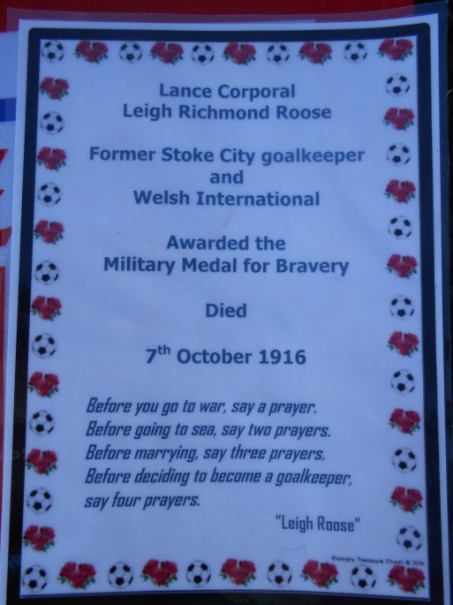
“Before you go to war, say a prayer.
Before going to sea, say two prayers.
Before marrying, say three prayers.
Before deciding to become a goalkeeper, say four prayers.”

Let us hope that the impact of both his life as a doctor and as a goalkeeper to his generation, though foreshortened, may be reflected in the respect which we are able to afford him almost 100 years later.

The community of Ypres today has a brand new football pitch opened in 2014 by Premier League Chief Executive Richard Scudamore at KVK Westhoek Club. This club is the venue for the annual Premier League ‘Christmas Truce’ International tournament.
The Premier Leagues gift to Ypres commemorates one of the most extraordinary acts in War History, when on Christmas Day 1914, soldiers ceased fighting and exchanged gifts, sang songs and played football in No Man’s Land.
There are many memorials in the area to the dead and missing of the First World War, but it is felt that this would be a living statue – with symbolic value – so that what happened in Ypres 100 years ago will be remembered as young people use sport to share something meaningful.

