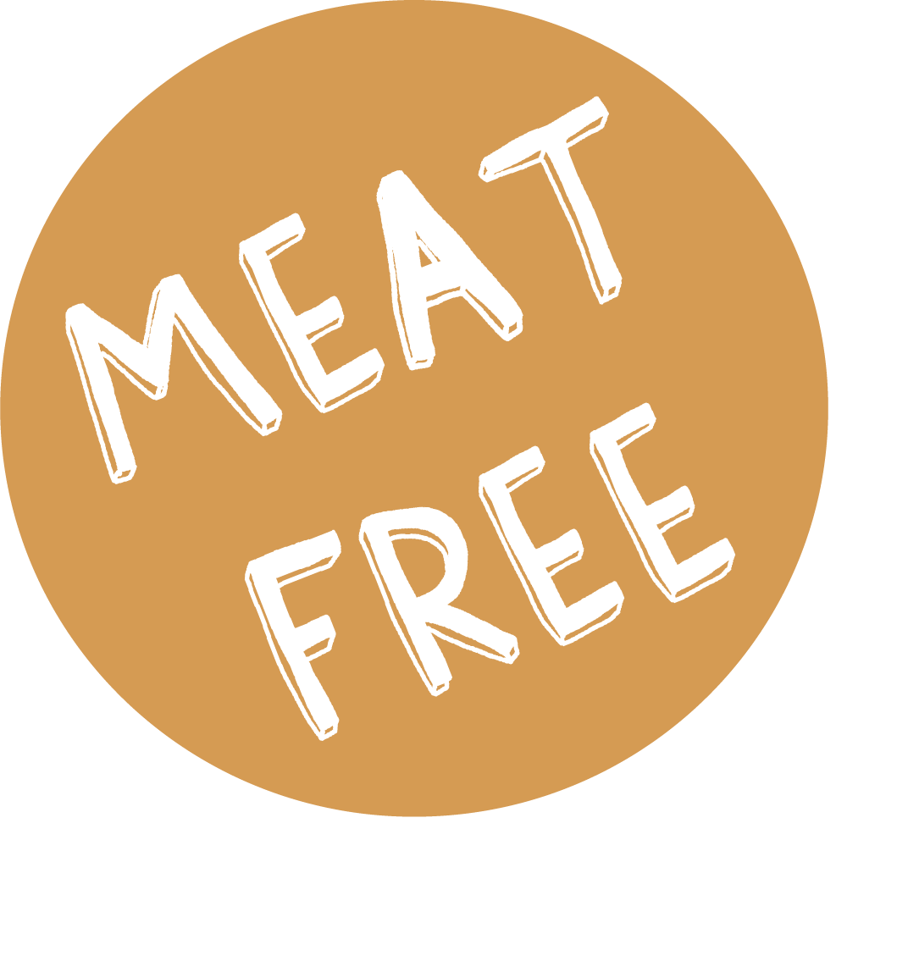

WEEK 1 | Monday | Tuesday | Wednesday | Thursday | Friday
MEAT MAIN DISH | AMERICAN BEEF BURGER & WEDGES | SWEET CHILLI CHICKEN NOODLES | ROAST PORK with ROAST POTATOES & STUFFING | TOAD in the HOLE & MASH POTATO | FISH & CHIPS
VEGETARIAN MAIN DISH | MACCARONI CHEESE | QUORN SWEET & SOUR & RICE | CHEESE & TOMATO TART | VEGETARIAN TOAD in the HOLE & MASH | VEG PASTY & CHIPS
ACCOMPANIMENTS | SALAD & COLESLAW | PEAS | CARROTS & CABBAGE | CARROTS & PEAS | MUSHY PEAS or BEANS
JACKET POTATO | TUNA, CHEESE, BEANS OR COLESLAW | TUNA, CHEESE, BEANS OR COLESLAW | TUNA, CHEESE, BEANS OR COLESLAW | TUNA, CHEESE, BEANS OR COLESLAW | TUNA, CHEESE, BEANS OR COLESLAW
DESSERT | COOKIE | ICECREAM & FRUIT | CHOCOLATE ORANGE COOKIE | FRUIT PIE & CUSTARD | FRUIT MUFFIN

