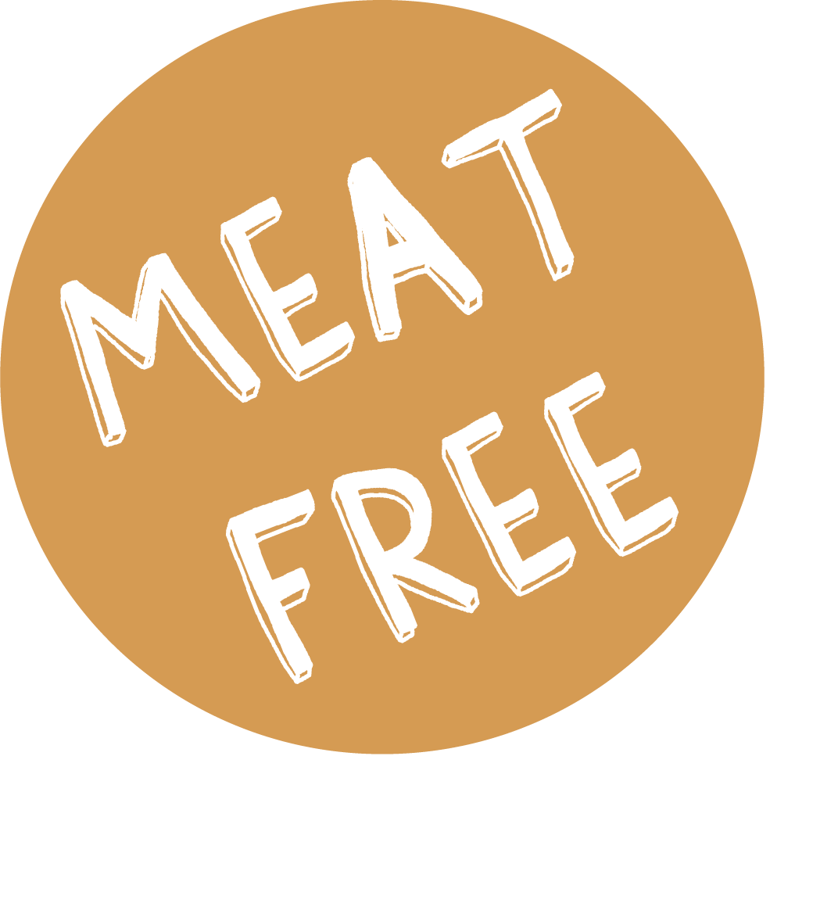

WEEK 2 | Monday | Tuesday | Wednesday | Thursday | Friday
MEAT MAIN DISH | LASAGNE & GARLIC BREAD | CHICKEN CURRY & NAAN | ROAST TURKEY, ROAST POTATOES & STUFFING | CHICKEN & VEG PIE | FISH & CHIPS
VEGETARIAN MAIN DISH | TOMATO & PASTA BAKE | GOBI ALOO CURRY & NAAN | CHEESE WHIRL & ROAST POTATOES | VEGETARIAN COTTAGE PIE | PIZZA
ACCOMPANIMENTS | GREEN BEANS & SWEETCORN | CARROTS | CARROTS & PEAS | BROCCOLI & SWEETCORN | MUSHY PEAS or BEANS
JACKET POTATO | TUNA, CHEESE, BEANS OR COLESLAW | TUNA, CHEESE, BEANS OR COLESLAW | TUNA, CHEESE, BEANS OR COLESLAW | TUNA, CHEESE, BEANS OR COLESLAW | TUNA, CHEESE, BEANS OR COLESLAW
DESSERT | COOKIE | PEAR SPONGE & CUSTARD | FRUIT FLAPJACK | APPLE CRUMBLE & CUSTARD | FRUIT MUFFIN

