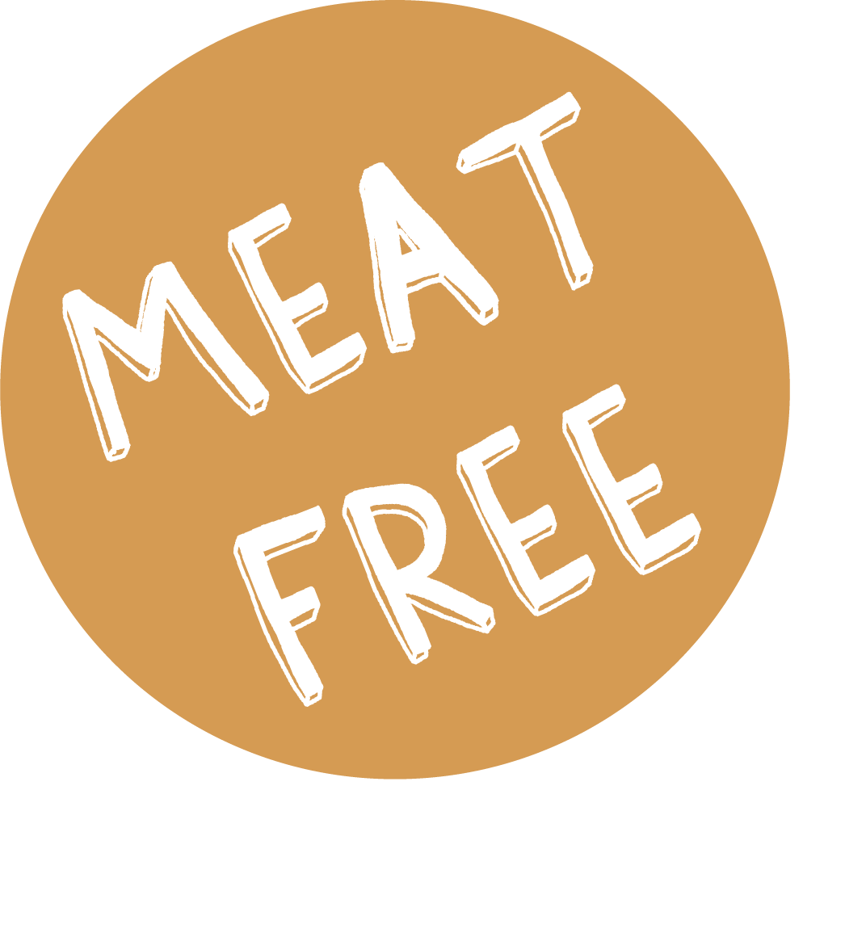

WEEK 3 | Monday | Tuesday | Wednesday | Thursday | Friday
MEAT MAIN DISH | BEEF QUESADILLA & HERBY POTATOES | CHICKEN & SWEETCORN PASTA with GARLIC BREAD | ROAST BEEF, YORKSHIRE PUDDING & MASH | CHICKEN CURRY & RICE | FISH & CHIPS
VEGETARIAN MAIN DISH | VEGETABLE BEAN BURRITO & HERBY POTATOES | VEGETABLE FRITTATA | CHEESE & POTATO PIE | SWEET POTATO & CHICKPEA CURRY & RICE | QUORN SAUSAGE
ACCOMPANIMENTS | CORN on the COB | SALAD & COLESLAW | CABBAGE & CARROTS | PEAS & SWEETCORN | MUSHY PEAS or BEANS
JACKET POTATO | TUNA, CHEESE, BEANS OR COLESLAW | TUNA, CHEESE, BEANS OR COLESLAW | TUNA, CHEESE, BEANS OR COLESLAW | TUNA, CHEESE, BEANS OR COLESLAW | TUNA, CHEESE, BEANS OR COLESLAW
DESSERT | COOKIE | FRUIT SPONGE & CUSTARD | OATY FRUIT CRUNCH | CARROT CAKE & CUSTARD | FRUIT MUFFIN

