Sixth Form Panto Trip
On Friday 5th January, The Meadows sixth form students went to the Regent Theatre to watch the pantomime…oh no they didn’t! OH YES THEY DID!!
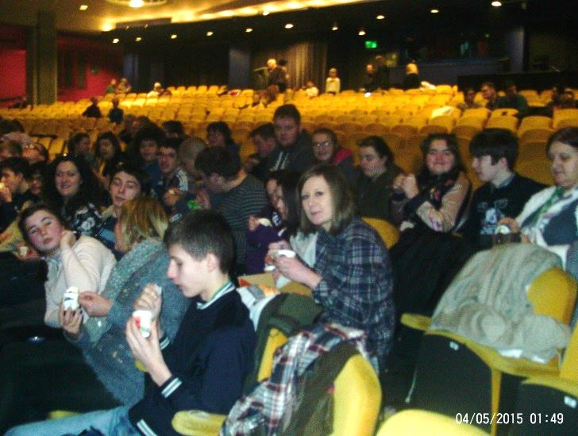
30 students went with staff to watch Aladdin. Everyone had such a brilliant time! We saw Aladdin fly on his magic carpet, and we even saw Princess Jasmine and the Genie. We had to wear special 3D glasses in some parts of the show, and we nearly got eaten by a crocodile! Everyone thoroughly enjoyed themselves, singing, chanting and cheering along with the actors, but the best part was definitely the vanilla ice cream that everyone had in the interval. The staff at the theatre commented on how well behaved and polite students from The Meadows School were and how they would love for us to go back and join them for another show very soon. Let’s hope we can convince Mrs Wright to let us see Robin Hood next year!
