Waterworld Trip
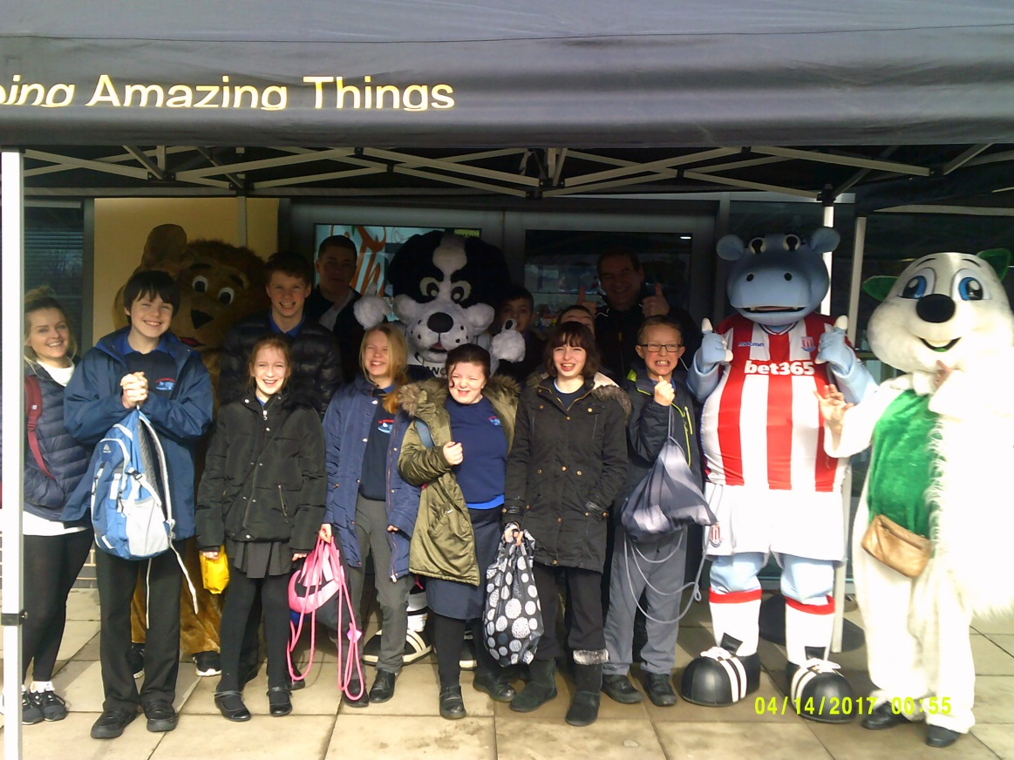

On Tuesday 6th March, students from The Meadows went to Waterworld for a fun session as part of an event organised by the Lions Club!
Students from across the school went with staff to Waterworld. Everyone had such a brilliant time! We were able to go on lots of slides like Space Bowl and the Rainbow Slides. There was even a slide that we went on in a rubber ring! Everyone thoroughly enjoyed themselves, splashing and cheering along with the students from other schools, but the best part was definitely the goody bag that everyone got at the end. The volunteers from the Lions commented on how well behaved and polite students from The Meadows School were and how they would love for us to go back and join them for the Waterworld event next year.

